**Assignment 1 – 50 Startups**

**By: 2313128 – S V Prissha**

**Steps:**

* The data set provided is 50 Startups.
* Initially upload the data set in Google Colab and then import the necessary libraries like pandas, numpy, matplotlib, sklearn etc.
* Read the file.
* Decide the dependent and independent variable from the data set.
* Do train test split, 80% of the data set is used to train the model and the rest 20% is used to the test the model and see its accuracy.
* Imported the pickle library for serialization.

**Simple Linear Regression:**

**Interpretation and result:**

1. **Variables:**

Dependent variable: Profit

Independent variable: R&D Spend

1. **R² Score: 0.927**

Inference: The R Square is 92.7%, which shows that the model is a good fit. 92.7% of the variation in Profit is explained by the variation in R&D Spend.

1. **Regression Equation:**

Intercept: 49336.668

Coefficient: 0.854

**Profit = 49336.668 + 0.854 * (R&D Spend)**

Inference: Which show that if the R&D Spend increases the profit will also increase by 0.854.

1. A graph of a graph with blue dots

   Description automatically generated with medium confidence**Scatter plot:**

The Diagram Shows a clear upward linear trend between the Profit and R&D Spend.

1. **Comparing the actual and predicted profit:**

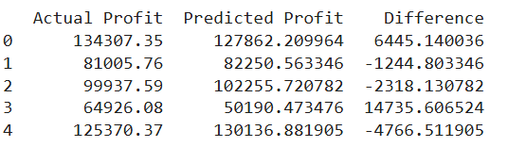

**Multiple Linear Regression:**

**Interpretation and Result:**

1. **Variables:**

Dependent Variable: Profit

Independent Variables: R&D Spend, Administration, Marketing Spend

1. **R Square = 0.900**

Inference: The R Square is 90%, which shows that the model is a good fit. 90% of the variation in Profit is explained by the variation in R&D Spend, Administration and Marketing Spend.

1. **Mean Squared Error: 80926321.223**

The MSE is high which shows there is deviation from the actual profits.

1. Regression Equation:

Intercept: 54071.87574599082

Coefficients: [ 0.80377928 -0.06792917 0.03124155]

**Profits = 54071.876 + 0.804 *(R&D Spend) – 0.068 *(Administration) + 0.031 *(Marketing Spend)**

Which show that if the R&D Spend increases the profit will also increase by 0.803

If the Administration increases the profit will decrease by 0.068.

If the Marketing Spend increases the profit will decrease by 0.031

1. **Comparing the actual profits and predicted profits:**

